Integrate 2018 – Sennheiser Showcases digital workflows

Sydney, August 21, 2018 – Integrate 2018 is Australia's premier annual AV and Integration trade show, taking place from 22-24 August at the ICC Sydney. Sennheiser will showcase its business solution products, with a key focus on the topic of Digital Workflows. The audio specialist will present software and products that facilitate the daily work of IT and AV professionals as well as end-users at stand H50. Visitors can learn about the new TeamConnect Ceiling 2, the latest updates in the SpeechLine Digital Wireless range, as well as MobileConnect and evolution wireless G4. The newly updated Sennheiser Control Cockpit Software will also be available for visitors to experience, which allows for simpler operation, control and servicing of Sennheiser microphones and network-enabled wireless devices.

Sennheiser aims to enhance the potential of its business solutions portfolio through powerful yet easy-to-use software that drives productivity, expressed at this year’s Integrate through the topic of Digital Workflows. “Integrate is a great opportunity to meet with our customers and show off the latest innovations in our business solutions portfolio.” explains Jason Grbevski, Product Channel Manager for Integrated Systems at Sennheiser Australia. “This year we are particularly excited to present our new TeamConnect Ceiling 2 and evolution wireless G4, and the ease with which all our systems can be integrated into Sennheiser’s Control Cockpit Software allowing for seamless digital workflows in any environment.”

Sennheiser Control Cockpit: Control of all your Sennheiser microphones and equipment
The Sennheiser Control Cockpit software simplifies the process of manually servicing microphones, especially where multiple microphones are dispersed among conference rooms, offices or auditoriums.
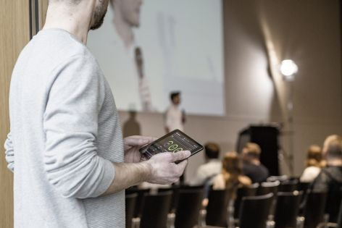 | Sennheiser Control Cockpit: Easy handling, control and maintenance of microphone systems in real time

The software provides an overview of all Sennheiser network enabled wireless devices at any time. The integrated dashboard gives an immediate overview of all microphones in the system so it’s easy for the user to rapidly assess the current status, while the real-time interaction between hardware and software allows system settings to be changed via remote access. Should a single microphone develop an issue, push messaging alerts the team member responsible who, in most cases, can address the situation from afar. This workflow optimisation saves an organisation time and money, while also improving the experience of employees.

TeamConnect Ceiling 2 update: Raise your meetings to a higher level
Sennheiser will be showcasing the next generation of its innovative ceiling microphone, TeamConnect Ceiling 2, at Integrate.

Ideal for mid to large sized meeting rooms, TeamConnect Ceiling 2 can be installed virtually invisibly into the ceiling to allow for truly flexible usage of a space. Its unique feature is its innovative, patented dynamic beamforming technology. Using 28 omni-directional microphone capsules, it focuses on the voice of a speaker in the room - regardless of their position - to make productive meetings effortless. It offers even greater versatility and interoperability with support for Dante networks and Power over Ethernet, and is compatible with Sennheiser’s Control Cockpit software for efficient remote management.

 | Complete freedom of movement and excellent speech intelligibility: TeamConnect Ceiling is the only conference room solution that works with automatic beamforming

On the stand there is also a TeamConnect Ceiling Virtual Reality Experience, which will show visitors the advantages of a ceiling microphone that is able to fully automatically align towards the speaker in a conference room.

SpeechLine Digital Wireless: Scalable and flexible for every environment
SpeechLine Digital Wireless is Sennheiser's wireless microphone system that is designed exclusively for speech applications, guaranteeing the highest speech intelligibility and concise sound quality.

The SpeechLine Digital Wireless series provides reliable and highly flexible solutions tailored to education and corporate applications, and is widely scalable for everyday working and lecturing environments - from small room setups to huge campus-wide installations.

Experience simplicity. SpeechLine Digital Wireless guarantees highest speech intelligibility and concise sound quality. | 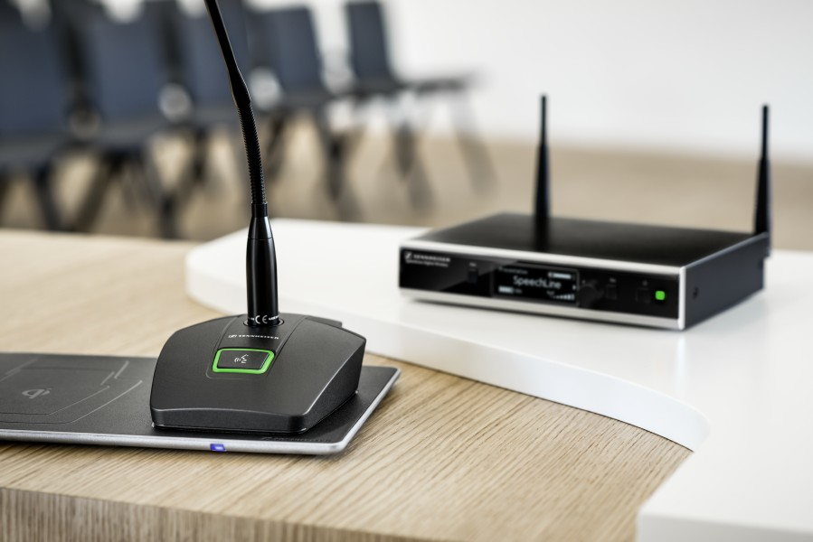
Installation, operation and adjustment are easier than those of any other microphone. Once the microphone has been configured, users do not require any audio know-how – it is already built-in. This enables speakers to focus entirely on their speech during meetings, lectures or presentations instead of having to think about the microphone they are using. The SpeechLine Digital Wireless series also has Dante support for IP network compatibility and can be effortlessly managed via the new Sennheiser Control Cockpit software.

MobileConnect: Personal Hearing Assistant
MobileConnect is a breakthrough product that delivers live, high–definition sound to mobile devices.
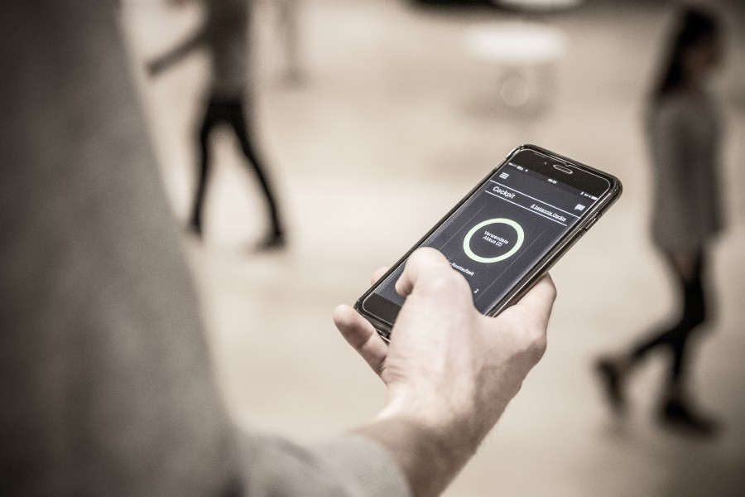 | Transmitting audio over WiFi in real-time  and in high-quality to mobile devices  and smartphones.

The universal system uses a Wi-Fi connection to stream lip-sync audio content to the user’s smartphone, which has an app that instantly converts it into a mobile receiver. The system consists of a ConnectStation, a central unit for integrating different audio streams and transmitting them via WiFi access points to the personal mobile devices. MobileConnect can be quickly and easily installed into event spaces, theatres, museums, university auditoriums or businesses.

evolution wireless G4: The next generation
Sennheiser’s evolution wireless portable systems have been an industry standard wireless solution for media, content creators as well as small and medium-sized broadcasters, business and education enterprises worldwide.

The evolution wireless 300 G4 series has been designed with the requirements of users in education and business environments in mind | 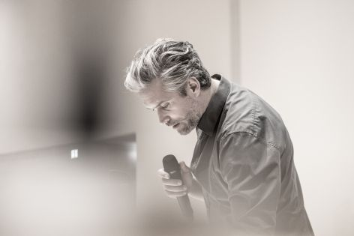

The fourth generation evolution wireless series makes professional wireless technology even more simple, flexible and reliable, and is fully compatible with all previous evolution wireless generations, safeguarding any earlier investments. The 300 series in particular is targeted for users in corporate, hospitality and education settings with their requirements in mind. An integrated network port allows for remote control and monitoring via the Wireless Systems Manager software and the Sennheiser Control Cockpit Software making it incredibly easy to control multichannel systems and ensure the perfect workflow.

Visit us at Integrate
To learn more about Digital Workflows with Sennheiser, visit us at Integrate (from 22 to 24 August) at stand H50, ICC, Darling Harbour. Global Portfolio Manager for Business Communication at Sennheiser, Kai Tossing, will be available to answer questions at the Sennheiser booth, and Sennheiser ANZ Product Channel Managers’ James Waldron, and Jason Grbevski, will be presenting “A Wireless Future – Insights on today’s technologies and what the future holds for wireless microphones” in the Integrate Live Theatre on Friday 24 August from 2-3pm. Click here to find out more: https://integrate-expo.com/whats-on/integrate-live/

About Sennheiser
Shaping the future of audio and creating unique sound experiences for customers – this aim unites Sennheiser employees and partners worldwide. Founded in 1945, Sennheiser is one of the world’s leading manufacturers of headphones, microphones and wireless transmission systems. With 21 sales subsidiaries and long-established trading partners, the company is active in more than 50 countries and operates its own production facilities in Germany, Ireland, Romania and the USA. Since 2013, Sennheiser has been managed by Daniel Sennheiser and Dr. Andreas Sennheiser, the third generation of the family to run the company. In 2017, the Sennheiser Group generated turnover totaling €667.7 million. www.sennheiser.com

Local Press Contact

Heather Reid
heather.reid@sennheiser.com
T +61 448 119 609

